1. You don’t need to create skeleton web app manually when working Spring boot.   
   Just use start.spring.io  
   STS by Spring Team has integration for start.spring.io with the help of REST.

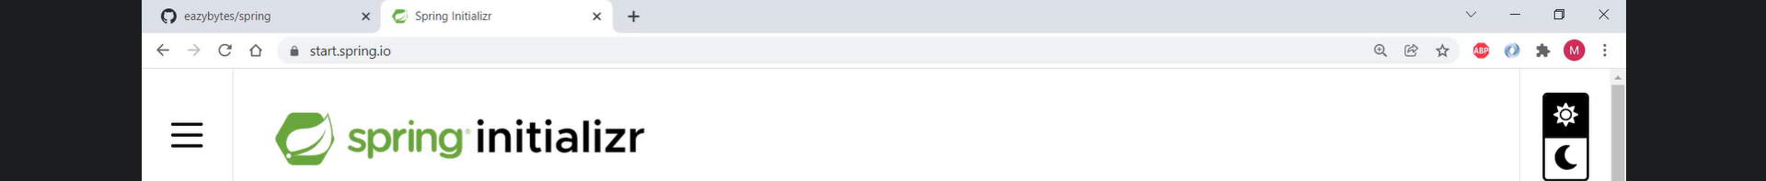  


1. Graphical user interface, text, application

   Description automatically generated
2. Graphical user interface, text, application

   Description automatically generated
3. Graphical user interface, text, application, email

   Description automatically generated